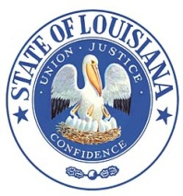 Louisiana State Board of Embalmers
and Funeral Directors
New Orleans, LA
Suite 1232, The Executive Towers
3500 N. Causeway Blvd.
Metairie, LA 70002
504.838.5109 www.lsbefd.state.la.us
FAX: 504.838.5112 Toll free: 888.508.9083

Notice regarding the Wallet License Card

At this time, the Board is unable to offer wallet license cards due to a change within the printing company.

The Board is reviewing other options for wallet cards to be provided to licensees, however, the pricing, fees and requirements so far have not been favorable.

Please note that the wallet card is not a requirement outlined within the regulations and is not a necessity.

If you have any questions, please do not hesitate to contact this office.

