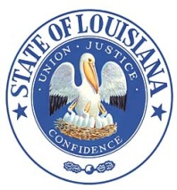 Louisiana State Board of Embalmers
and Funeral Directors
New Orleans, LA
Suite 1232, The Executive Towers
3500 N. Causeway Blvd.
Metairie, LA 70002
504.838.5109 www.lsbefd.state.la.us
FAX: 504.838.5112 Toll free: 888.508.9083

Notice of Meeting
Monday – March 5, 2018
10:30 AM
Meeting of the Laws & Rules Committee

Agenda

10:30 AM

◯ 1. Agenda - Call to order

Compliance
◯ 2. Review of rules:
Chapter 7. § 701.
Chapter 9. § 905.
Chapter 19. §1901.

◯ 3. Additional comments/suggestions for rule changes

◯ 4. Conclusion of meeting – any final statements/notifications and/or closing remarks

